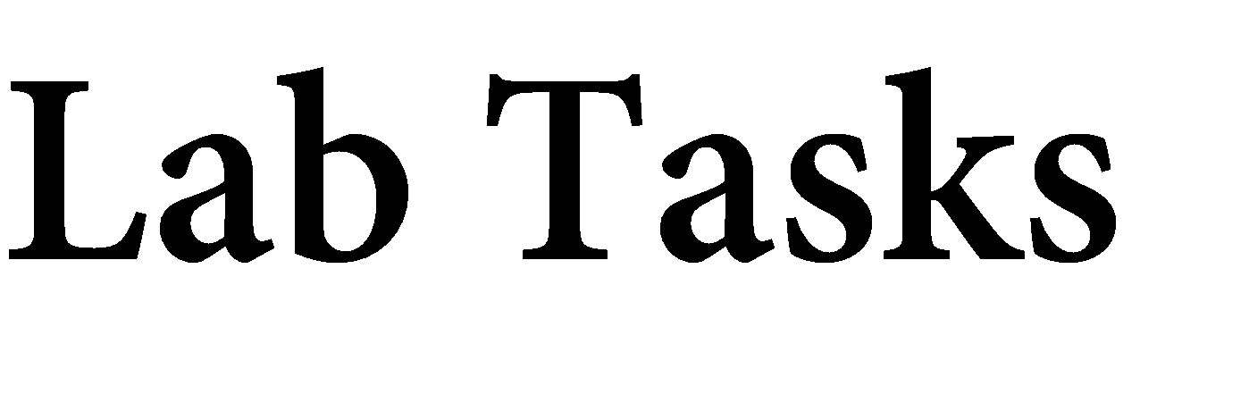

Name: Muhammad Faisal
Roll no: 2022F-BCS-152

Section: A
Instructor Name: Miss Fozia Khan
Course: Artificial Intelligence Lab (CS - 325L)
Program: (BS) - Computer Science

Lab #01
Activity- 1:
Write a script that take user input for a number then adds 3 to that number. Then multiplies the result by 2, subtract 4, then again adds 3, then print the result.
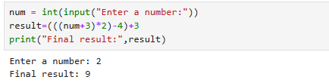

Activity- 2:
Write a script that takes input as radius then calculate area of circle. (Hint: A= πr²).
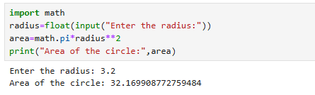

Activity- 3:
Write a Python script that asks users for their favourite color. Create the following output
(assuming blue is the chosen color) (hint: use „+‟ and „*‟)
blueblueblueblueblueblueblueblueblueblue
blue blue
blueblueblueblueblueblueblueblueblueblue
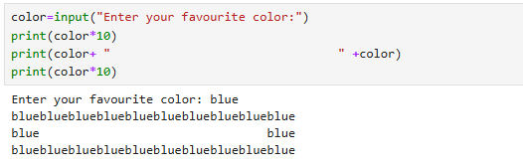

Activity- 4:
Store a person‟s name, and include some „*‟ characters at the beginning and end of the name. Print the name once, so the „*‟ around the name is displayed. Then print the name using each of the three stripping functions, lstrip(), rstrip(), and strip().
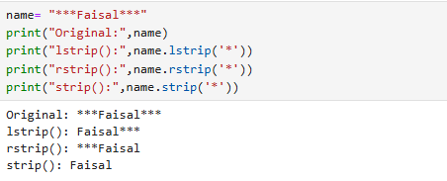

Activity- 5:
Write a function called absolute_num() that accepts one parameter, num. The function should return only positive value, and apply condition on it. This function returns the absolute value of the entered number.
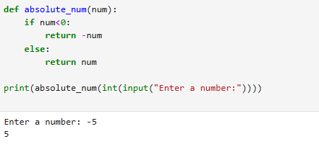

Activity- 6:
Write a function called describe_city( ) that accepts the name of a city and its country. The function should print a simple sentence, such as Karachi is in Pakistan. Give the parameter for the country a default value. Call your function for three different cities, at least one of which is in the default country.
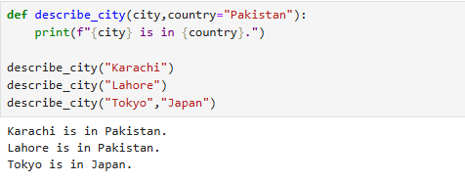

Activity- 7:
Write a python script that take a user input and to create the multiplication table (from 1 to 10) of that number.

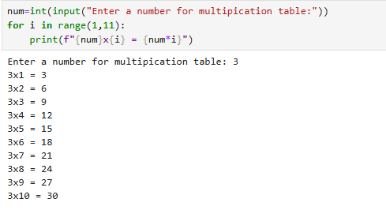

Activity- 8:
Write a Python program that prints all the numbers from 0 to 6 except 3 and 6.
Note: Use 'continue' statement.
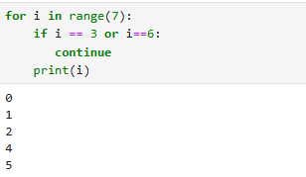

Activity- 9:
Stages of Life: Write an if-elif-else chain that determines a person‟s stage of life. Set a value for the variable age, and then:
- If the person is less than 2 years old, print a message that the person is a baby.
- If the person is at least 4 years old but less than 13, print a message that the person is a kid.
- If the person is at least 13 years old but less than 20, print a message that the person is a teenager.
- If the person is at least 20 years old but less than 65, print a message that the person is an adult.
- If the person is age 65 or older, print a message that the person is an old.
